**Tekart Revision Series**

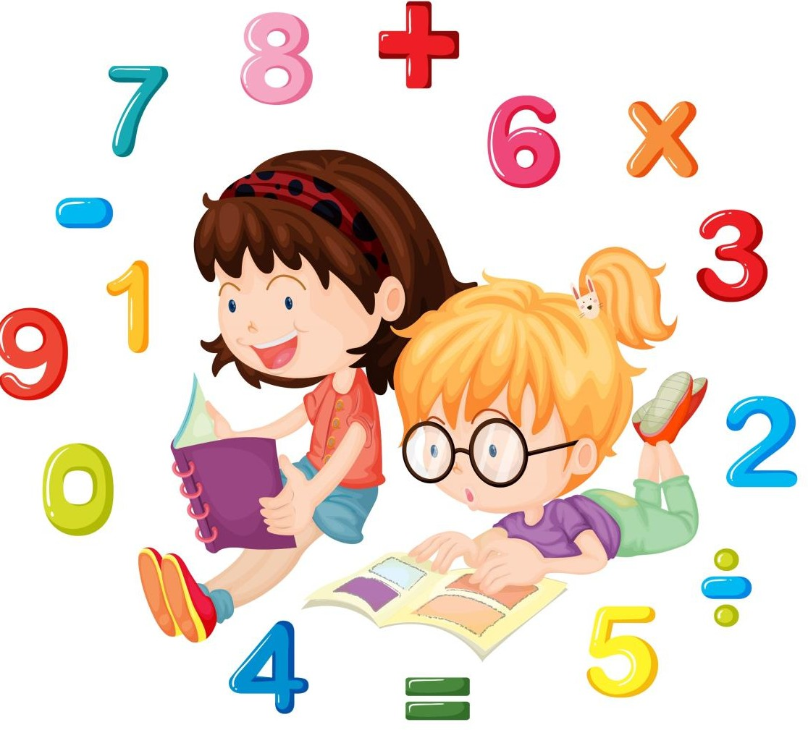

**Topical Questions**

2

www.tekartlearning.com

|  |  |  |
| --- | --- | --- |
|  |  | LITERACY II TERM I  **Theme one: Our school and neighbourhood**   1. What is a school? 2. Name the district where your school is found. 3. Give any two school symbols. 4. What school symbol encourages pupils to work hard? 5. Write down your school box number. 6. Draw these school symbols.   School uniform School flag   1. What are school structures? |
|  |  | 8. Match correctly.  Toilets where food is prepared. |

|  |  |
| --- | --- |
|  |  |
|  |  |

|  |  |  |
| --- | --- | --- |
|  |  | Sick bay where school property is kept.  Store where we go to ease ourselves.  Kitchen where sick pupils rest. 9.   1. Name the type of house shown. 2. Write down two materials we use to build this house. 3. I am a building material. People use me to build a hut. I am got from a cow. What am I? 4. Write ‘**True**’ or ‘**False**’    1. A watchman is not found at school.    2. Matrons look after children in the boarding school.    3. Cleaners teach pupils. 5. What do we call children with special duties at school? 6. Name these needs at school. |



1. Mention any two ways in which a school meets its needs.

**Theme two: Our home and community**

1. A is a group of people related by blood or marriage.
2. What is a nuclear family?

Grand parents

1. Complete this family relationship.

mother

1. How do we call the following people?
   1. The daughter of your father or mother.
   2. The sister of your father or mother.
2. Name the people who start a family.
3. What is a community?
4. Draw and name any two types of communities.
5. Match people with their roles.

Shepherd Doctor Cobbler Police officer Fishmonger

sells fish

keeps law and order looks after sheep treats sick people mends shoes

1. Give the places of work for the following people.
   1. carpenter
   2. mechanic
   3. barber
   4. shop keeper
2. From the list below, write out things which make up culture. greeting a. fighting b.

|  |  |  |
| --- | --- | --- |
|  |  | dressing c. abusing d. worshipping  killing  singing and dancing  11. What do we call children born on the same day by the same mother? |
|  |  | LITERACY II TOPICAL QUESTIONS FOR P.2 TERM I NO. 3  **Theme three: The human body and health**   1. Name parts of a head. 2. What do we call the general cleanliness of a place (environment) where we stay or live? 3. Why do we keep our homes clean? 4. Which materials do we use to keep these places clean? 5. Classrooms 6. Toilets |

|  |  |  |
| --- | --- | --- |
|  |  | 1. How do we keep our classrooms clean? (Give any two ways) 2. Give the uses of these items.   (a)  (b)  7. Why do we keep our body clean? Give any two reasons.    2. 1. is the way of keeping our body clean. (Sanitation, person hygiene)    2. Draw these things we use to clean our body.    3. Write **correct** or **incorrect**.       1. We boil water to kill germs.       2. Malaria is an immunisable disease.       3. We brush our teeth to prevent tooth decay. |

|  |  |  |
| --- | --- | --- |
|  |  |  |
| Soap | Razorblade | Nail cutter |

|  |  |  |
| --- | --- | --- |
|  |  | 1. Why do we sleep under a mosquito net? 2. Name any two common diseases.   **Theme Four: The human body and health**   * + 1. What is food?     2. Name any two common food in the community.   3. Why do we eat food? Give any two reasons.    2. 1. Draw a line under sources of food.   **market, school, garden, workshop, bakery**   * 1. Name this food we get from water.      * 1. How many classes of food do we have?   2. **Match correctly** |

|  |  |  |
| --- | --- | --- |
|  |  | Body building food vitamins  Energy giving food proteins  Health giving food carbohydrates   1. What disease can you suffer from when you lack enough Proteins in the body   Carbohydrates in the body  (scurvy, marasmus, kwashiorkor )   1. Give any two examples of food eaten raw. 2. Give one importance of a balanced diet. 3. Tick the effects of poor feeding. Death   Loss of weight Malnutrition dullness   1. Mention two ways of preparing food. 2. Why do we boil water for drinking? |

|  |  |  |  |  |  |  |
| --- | --- | --- | --- | --- | --- | --- |
|  |  | 1. What is food hygiene? 2. Name this way of preserving food. | | | | |
|  |  | **TERM 11 P.2 LITERACY II THEME 1: OUR ENVIRONMENT**   1. What is environment?   ………………………………………………………………………………………….   1. List down any four components of environment.   a. ………………………………………..….c. ……………………………………..  b. …………………………………………….d. .……………………………………   1. Draw and name any three things found in our environment. | | | | |
|  |  |  |  |  |
|  |  |  |
| 1. Write down two groups of living things.   a. ………………………………………….b. ..…………………………………….   1. What are living things?   ……………………………………………….…………………………………………   1. What are plants called living things?   ………………………………………….………………………………………………   1. Identify any three examples of non-living things.   ………………………………………………………………………………………… | | | | |

|  |  |  |  |  |  |
| --- | --- | --- | --- | --- | --- |
|  |  | 1. Define the term environment.   ……………………………………….…………………………………………………   1. Write down any three characteristics of living things.   a. ………………………………………………………………………………………  b. ………………………………………………………………………………………  c. ………………………………………………………………………………………   1. What are domestic animals?   ………………………………………………………………………………………….   1. Draw and name any two animals kept at home. | | | |
|  |  |  |  |
|  |  |
| 1. How useful are dogs to people?   ………………………………………………………………………………………………   1. Why do people keep animals at home? (Write three reasons) a. ………………………………………………………………………………………….   b. ………………………………………………………………………………………….  c. …………………………………………………………………………………………. | | | |
|  |  | * 1. **LITERACY II**      1. Identify the two types of animals.   a. ………………………………………… b. ……………………………………   * + 1. Write their young ones. | | | |

|  |  |  |
| --- | --- | --- |
|  |  | sheep ………………………………………………………..  man ……………………………………………………….  fish ………………………………………………………..  rabbit ………………………………………………………..  frog ………………………………………………………..  cat ……………………………………………………….  cow ………………………………………………………..   1. Match correctly.   cow mutton  pig fillet  rabbit beef  fish pork  sheep rabbit pie   1. List down any two ways of caring for animals.   a. …………………………………………………………………………………………..  b. …………………………………………………………………………………………..   1. What are wild animals?   …………………………………………………………………………………………..   1. Name any three place where we find wild animals.   i. ………………………………………(iii)…………………………………….  ii. ………………………………………   1. Write out wild animals.   cow …………………………………………………………………  lion ………………………………………………………………..  tiger ………………………………………………………………..  sheep buffalo   1. What is a weapon? |

|  |  |  |
| --- | --- | --- |
|  |  | …………………………………………………………………………………………  9. How do these animals protect themselves?  cat …………………………………………………………………  man …………………………………………………………………  bee …………………………………………………………………  chameleon …………………………………………………………………. |
|  |  | * 1. **LITERACY II**      1. List down any three common insects in our environment.   a. ……………………………………… c...…………………………………………  b. ………………………………………   * + 1. Which part do insects use for breathing?   ……………………………………………………………………………………….   * + 1. How useful are bees to people?   ……………………………………………………………………………………….     * + - 1. Name this plant.   ………………………………………………………………………………………   * + - 1. Name the local material we get from this plant.   ………………………………………………………………………………………   * + 1. How do we protect ourselves from harmful insects. Give any three ways.   a. …………………………………………………………………………………………..  b. …………………………………………………………………………………………..  c. ………………………………………………………………………………………….. |

|  |  |  |
| --- | --- | --- |
|  |  | d. A young plant is called a ……………………………………………………..  e. What is mulching?  …………………………………………………………………………………………..   1. Name these parts of a plant.      1. What is germination?   ……………………………………………………………………………………………..   1. Identify any three conditions necessary for seed germination. a. …………………………………c. …………………………………   b. …………………………………   1. Which part of a bird helps it to fly?   …………………………………………………………………………………………..   1. Name the larva stages of these insects.   butterfly ………………………………………………………………………………….  cockroach…………………………………………………………………………………  housefly …………………………………………………………………………………..   1. Name these parts of an insect. |

|  |  |  |
| --- | --- | --- |
|  |  |  |
|  |  |  |

|  |  |  |  |  |  |  |  |
| --- | --- | --- | --- | --- | --- | --- | --- |
|  |  | **THEME 2:THINGS WE MAKE**   1. What are crafts?   …………………………………………………………………………………………….   1. Draw and name any four play materials. | | | | | |
|  |  |  |  |  |  |
|  |  |  |  |
| 1. List down any two things we use in the kitchen.   a. …………………………………… b. ………………………………………   1. Why do we make the following crafts? a.   b.  c.  d.   1. Name the materials we use to make;-   a. ropes …………………. c. baskets ……………………………… | | | | | |



|  |  |  |
| --- | --- | --- |
|  |  | b. mats …………………….   1. **Write** true or **false**.    1. A carpenter makes things out of metal. ………………………………   b) A potter makes pots ………………………………………………………..   1. A blacksmith makes things out of iron. ………………………………… 2. A welder makes things from wood. 3. The diagram below is an example of a craft.      * 1. How is it useful to people?   …………………………………………………………………………………………..   * 1. Name the local material from which it is made.   ………………………………………………………………………………………….   * 1. Identify one place where it can be found.   …………………………………………………………………………………………..   1. Identify any three materials got from the factory.   a. ………………………………… c. ………………………………….  b. ………………………………… |
|  |  | **TOPICAL REVISION NO. 4**  **P.2 LITERACY II**  **THEME 3: TRANSPORT AND COMMUNICATION IN OUR COMMUNITY**   1. What is transport?   ……………………………………………………………………………………………   1. List down types of transport.   a. ………………………………………… c. ………………………..………………….. |

|  |  |  |
| --- | --- | --- |
|  |  | b. ………………………………………… d.…………………………………………….   1. List out means of water transport.   bus …………………………………………………………………………  ship …………………………………………………………………………  parachute ……………..…………………………………………………………..  boat ferry taxis   1. Write down any three people who use the road.   a. …………………………………… c ………………………………………  b. ……………………………………   1. Underline the traffic rules.    1. No driving while talking on phones.    2. Driving bad cars    3. Over loading    4. We should drive while drunk 2. Identify any three safe ways of using the road.   a. …………………………………………………………………………………………..  b. …………………………………………………………………………………………..  c. …………………………………………………………………………………………..   1. How is transport important? Give any three ways.   a. …………………………………………………………………………………………..  b. …………………………………………………………………………………………..  c. ………………………………………………………………………………………….. |

|  |  |  |
| --- | --- | --- |
|  |  | 1. Name these road signs.   ……………………………………………….  ……………………………………………….  ………………………………………………   1. Write down any three ways of preventing road accidents.   a. …………………………………………………………………………………………..  b. …………………………………………………………………………………………..  c. ………………………………………………………………………………………….. |
|  |  | **TOPICAL REVISION NO. 5**  **P.2 LITERACY II THEME 4 ACCIDENT AND SAFETY**   1. What is an accidents?   …………………………………………………………………………………………..   1. Identify any three common accidents at home and school.   a. ……………………………………… c. ………………………………………  b. ………………………………………   1. Write out the effect of accidents from the list. Love |



obedience death

good relationship poverty lameness

…………………………….

…………………………….

……………………………

1. The first help given to an injured person is called

…………………………………………………………………………………………..

1. Who is a casualty?

…………………………………………………………………………………………..

1. Why do we give first aid? Give three reasons.

i. ………………………………………………………………………………….

ii. ………………………………………………………………………………….

iii. ………………………………………………………………………………….

1. Draw and name any three things that cause accidents.
2. Name any two places where we find first aid boxes.

a. ………………………………………………………………………………………

b. ………………………………………………………………………………………

1. Write down any three ways of preventing accidents at home and school.

a. …………………………………………………………………………………………..

b. …………………………………………………………………………………………..

c. …………………………………………………………………………………………..

1. What first aid can you give to a person who has cut him/herself?

…………………………………………………………………………………………..

1. Why do we need a razorblade in a first aid box?

………………………………………………………………………………………….

1. Draw a first aid box.

www.tekartlearning.com ©Tekart Learning Revision Books